Promoted for and on behalf of Cycling Time Trials under its Rules and Regulations

CRAIG WESTON MEMORIAL 10 MILE TIME TRIAL
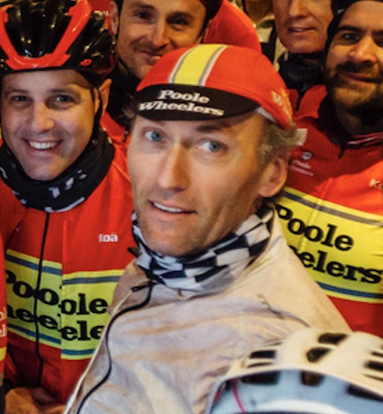
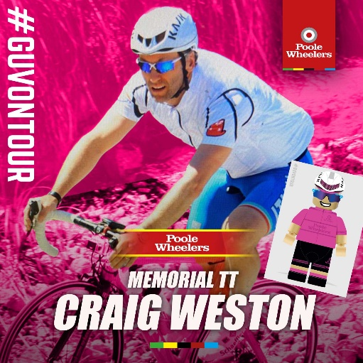
SUNDAY 17th September 2023

Organiser: Steven Pink, 6 Granary Hill, Charminster, Dorchester DT2 9SZ.
07920 484070 stevenpink@ymail.com
Volunteers:
Signing on Graham Hurst, Poole Wheelers
Start Timekeeper Bev Wadsley, Poole Wheelers
Start Supervisor Laurie King
Finish Timekeeper Ros Spencer Poole Wheelers
Recorder Marcia Rendell Poole Wheelers
Number Spotter William Terry
Refreshments Sarah King & Catherine Weston
Results Service Pete & Suzy Watkins

PRIZE LIST TT
First man £25 First lady £25
Second man £15 Second lady £15
Third man £10 Third lady £10

PRIZE LIST Road Bikes

First man £25 First lady £25
Second man £15 Second lady £15
Third man £10 Third lady £10

PRIZE LIST (Across Road or TT bikes)

First vet on Std £25 First Junior/Juvenile £25
Second vet on Std £15 Second Junior/Juvenile £15
Third vet on Std £10 Third Junior/Juvenile £10

Fastest team £10 each

There will be spot prizes for 10th/20th/30th/40th/50th/60th/70th overall of a bottle of Craig’s “Guv” wine (a small cash alternative if anyone under 18 wins one)

A PRIZE PRESENTATION WILL TAKE PLACE AFTER THE EVENT SO PLEASE STAY FOR THAT. PLEASE NOTE ONE PRIZE PER RIDER APART FROM THE TEAM PRIZE.

After the presentation there will be a raffle in aid of Craig’s charities. We have over £500 worth of cycling related prizes donated by Neil Watts of Fit to Ride. Prizes include several top of the range Kask helmets. Please bring cash to purchase tickets.

IF YOU ARE NOT WELL OR ARE SHOWING SIGNS OF COVID-19 THEN PLEASE DO NOT COME TO THIS EVENT.
REMEMBER WORKING REAR AND FRONT LIGHT.

All competitors must wear protective hard-shell helmets.

P412 COURSE:

Start at exit of bulbury lane onto a35, 8 yards east of speed restriction sign & 40 yards west of bus stop.proceed on a35 eastbound to bakers arms rbt (1.65).straight on along a35 to turn at holes bay rbt (5.21).circle and retrace to bakers arms rbt (8.80).take 2nd exit (straight on) on a35 to finish on a35 by the drain cover in the lay by opposite the entrance to newtons farm.

No U turns within sight of the start or finish, no warming up on the course after the event has started please.

Please do not park near the golf course or obstruct their entrance, we’ve had a good relationship with the golf club and would like to maintain this.

The fire station emergency lights at Holes Bay Roundabout are operational, any rider observed going through a red light will be disqualified and South DC will be informed.

WHEN APPROACHING BAKERS ARMS ROUNDABOUT, COMPETITORS MUST KEEP TO THE LEFT UNTIL THEY HAVE PASSED THE LEFT HAND “REDUCE SPEED NOW” SIGN. RIDERS NOT ADHERING TO THIS RISK BEING DISQUALIFIED.

Headquarters:

Lytchett Matravers Village Hall, High Street, Lychett Matravers, Poole BH16 6DF.

The HQ will be open from 6am when signing on etc will commence. Do not forget to SIGN OUT after the event, failure to do so will result in disqualification. Please return and exchange your number for a free tea or coffee at the end.

To get to the start (allow around 10 minutes) Turn right out of the HQ car park, then immediately right by the Rose and Crown. After passing the last houses in the village, turn right again and folow the road past the golf course entrance and on to the start by the A35 junction.

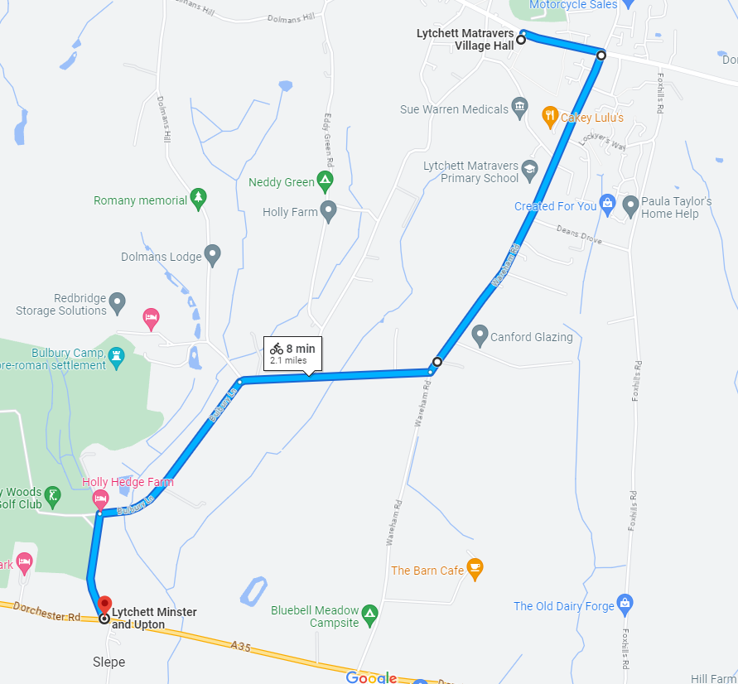

When you have finished, please carry on and cycle back to where the start line is and turn right, retracing your route to the HQ. DO NOT PERFORM A U-TURN at the finish!

Tea/coffe and refreshments will be at the HQ, you can exchange your number for a free drink. Please remember to bring old fashion money to but more tea, coffee and cake.

Start Sheet
Bib No | First name | Surname | Club | Gender | Category | Machine | Start Time | LTS
30 | Les | Pick | Poole Wheelers Cycling Club | Male | Veteran | Tandem | 07:30 | 22:36
31 | Steven | Pink | Poole Wheelers Cycling Club | Male | Veteran | Tandem | 07:30 | 19:36
32 | Ben | Ansell | Poole Wheelers Cycling Club | Male | Veteran | Road | 07:32 | 25:50
33 | Dave | Pickett | Poole Wheelers Cycling Club | Male | Veteran | Road | 07:33 | 25:30
34 | Mark | Luker | Poole Wheelers Cycling Club | Male | Veteran | Road | 07:34 | 25:00
35 | Olivia | Chaffey | Poole Wheelers Cycling Club | Female | Senior | Road | 07:35 | 38:00
36 | Liz | Cook | Poole Wheelers Cycling Club | Female | Veteran | Road | 07:36 | 35:00
37 | Goldie | Lockes | Poole Wheelers Cycling Club | Male | Senior | Road | 07:37 | 30:00
38 | Nick | Henson | Poole Wheelers Cycling Club | Male | Veteran | Road | 07:38 | 30:00
39 | Oakely | Richards | Bournemouth Cycleworks | Male | Espoir | Road | 07:39 | 29:32
40 | Joe | Simons | Poole Wheelers Cycling Club | Male | Senior | Road | 07:40 | 29:30
41 | Alun | Lewis | Poole Wheelers Cycling Club | Male | Veteran | Road | 07:41 | 27:33
42 | Phil | Harvey | Bournemouth Jubilee Whs | Male | Veteran | Road | 07:42 | 26:23
43 | Emma | Twine | Poole Wheelers Cycling Club | Female | Senior | Road | 07:43 | 26:15
44 | Brian | Burgess | GS Vecchi | Male | Veteran | Road | 07:44 | 26:02
45 | Jonathan | Clemas | Bournemouth Cycleworks | Male | Senior | Road | 07:45 | 26:00
46 | Pep | Niemeijer | Poole Wheelers Cycling Club | Male | Veteran | Road | 07:46 | 25:00
47 | Ryan | Symington | Poole Wheelers Cycling Club | Male | Espoir | Road | 07:47 | 24:50
48 | Michael | O'Driscoll | Poole Wheelers Cycling Club | Male | Senior | Road | 07:48 | 24:45
49 | Andrew | Thomas | Poole Wheelers Cycling Club | Male | Veteran | Road | 07:49 | 24:00
50 | Dave | Dent | GS Stella | Male | Veteran | Road | 07:50 | 23:36
51 | Kieran | Graham | Poole Wheelers Cycling Club | Male | Senior | Road | 07:51 | 23:30
52 | Ashley | Newman | Primera-Teamjobs | Male | Senior | Road | 07:52 | 22:03
53 | Thomas | Briers | Loughborough Students CC | Male | Senior | Road | 07:53 | 22:00
54 | Dan | Newman | Poole Wheelers Cycling Club | Male | Espoir | Road | 07:54 | 21:48
55 | Tom | Nancarrow | Poole Wheelers Cycling Club | Male | Senior | Road | 07:55 | 20:07
56 | Peter | Bowen | Poole Wheelers Cycling Club | Male | Veteran | TT Bike | 07:56 | 30:00
57 | Sarah | Inwood | Poole Wheelers Cycling Club | Female | Senior | TT Bike | 07:57 | 28:00
58 | Denzil | Hunt | Poole Wheelers Cycling Club | Male | Veteran | TT Bike | 07:58 | 27:48
59 | Robert | Flynn | Poole Wheelers Cycling Club | Male | Veteran | TT Bike | 07:59 | 27:00
60 | Simon | Berogna | Velo Club St Raphael | Male | Veteran | TT Bike | 08:00 | 20:15
61 | Andy | Haas | Poole Wheelers Cycling Club | Male | Veteran | TT Bike | 08:01 | 26:55
62 | Gary | Tuskin | Poole Wheelers Cycling Club | Male | Veteran | TT Bike | 08:02 | 26:35
63 | Gordon | Scott | CC Weymouth | Male | Veteran | TT Bike | 08:03 | 25:56
64 | Terry | Belbin | Poole Wheelers Cycling Club | Male | Veteran | TT Bike | 08:04 | 25:24
65 | George | Terry | Poole Wheelers Cycling Club | Male | Juvenile | TT Bike | 08:05 | 25:03
66 | Sian | McPherson | Poole Wheelers Cycling Club | Female | Senior | TT Bike | 08:06 | 24:38
67 | Ian | Turner | Poole Wheelers Cycling Club | Male | Veteran | TT Bike | 08:07 | 24:33
68 | Lauren | Falconer | Poole Wheelers Cycling Club | Female | Senior | TT Bike | 08:08 | 24:26
69 | Robert | Fall | Poole Wheelers Cycling Club | Male | Junior | TT Bike | 08:09 | 24:22
70 | Jonathan | Legg | Sotonia CC | Male | Veteran | TT Bike | 08:10 | 24:01
71 | Neil | Watts | Poole Wheelers Cycling Club | Male | Veteran | TT Bike | 08:11 | 24:00
72 | Oliver | Drew | Poole Wheelers Cycling Club | Male | Senior | TT Bike | 08:12 | 23:21
73 | Michael | Naulls | Velo Club Venta | Male | Veteran | TT Bike | 08:13 | 23:17
74 | James | Rowat | Poole Wheelers Cycling Club | Male | Veteran | TT Bike | 08:14 | 23:15
75 | Gary | Chiverton | Bournemouth Jubilee Whs | Male | Veteran | TT Bike | 08:15 | 23:09
76 | Paul | Axon | Poole Wheelers Cycling Club | Male | Veteran | TT Bike | 08:16 | 23:00
77 | Chris | Murray | Army Cycling | Female | Veteran | TT Bike | 08:17 | 22:48
78 | Stuart | Thompson | Velo Club St Raphael | Male | Veteran | TT Bike | 08:18 | 22:42
79 | Stuart | Peckham | Velo Club St Raphael | Male | Veteran | TT Bike | 08:19 | 22:39
80 | Chris | Hill | Poole Wheelers Cycling Club | Male | Veteran | TT Bike | 08:20 | 22:37
81 | Matt | Blythe | Poole Wheelers Cycling Club | Male | Veteran | TT Bike | 08:21 | 22:31
82 | Peter | Perrin | Bournemouth Arrow CC | Male | Veteran | TT Bike | 08:22 | 22:24
83 | Doug | Parker | Sid Valley CC | Male | Veteran | TT Bike | 08:23 | 22:19
84 | Keith | Mabbott | Royal Navy & Royal Marines CA | Male | Veteran | TT Bike | 08:24 | 22:15
85 | Tom | Cox | Saint Piran | Male | Veteran | TT Bike | 08:25 | 22:50
86 | Chris | Martin | 1st Chard Wheelers | Male | Veteran | TT Bike | 08:26 | 22:14
87 | Patrick | Dunn | CC Weymouth | Male | Veteran | TT Bike | 08:27 | 22:09
88 | Patrick | Mahon | Poole Wheelers Cycling Club | Male | Veteran | TT Bike | 08:28 | 22:09
89 | Rufus | King | Poole Wheelers Cycling Club | Male | Juvenile | TT Bike | 08:29 | 22:08
90 | Kirsty | McSeveney | ...a3crg | Female | Veteran | TT Bike | 08:30 | 22:06
91 | David | Butt | CC Weymouth | Male | Veteran | TT Bike | 08:31 | 21:43
92 | Michael | Akers | New Forest CC | Male | Senior | TT Bike | 08:32 | 21:30
93 | Colin | Brumble | CC Weymouth | Male | Veteran | TT Bike | 08:33 | 21:18
94 | Nathan | Willmington | CC Weymouth | Male | Veteran | TT Bike | 08:34 | 21:10
95 | Bob | Richardson | Bournemouth Jubilee Whs | Male | Veteran | TT Bike | 08:35 | 21:08
96 | Jamie | Franklin | Velo Club Venta | Male | Veteran | TT Bike | 08:36 | 21:03
97 | Stephen | Morphew | Poole Wheelers Cycling Club | Male | Senior | TT Bike | 08:37 | 21:03
98 | Tim | Flynn | Poole Wheelers Cycling Club | Male | Senior | TT Bike | 08:38 | 20:57
99 | William | Sawyer | Velo Club St Raphael | Male | Veteran | TT Bike | 08:39 | 20:53
100 | Noah | Miller-Pipe | Poole Wheelers Cycling Club | Male | Senior | TT Bike | 08:40 | 20:50
101 | Ryan | Weston | Poole Wheelers Cycling Club | Male | Senior | TT Bike | 08:41 | 20:45
102 | Adrian | Talley | Velo Club St Raphael | Male | Veteran | TT Bike | 08:42 | 20:25
103 | Alex | Rowling | Poole Wheelers Cycling Club | Male | Senior | TT Bike | 08:43 | 19:42
104 | Tom | Clements | Wessex Road Club | Male | Veteran | TT Bike | 08:44 | 19:23
105 | Larry | Wiltshire | Chichester City Riders | Male | Veteran | TT Bike | 08:45 | 19:20
106 | Jamie | Whitcher | Bournemouth Cycleworks | Male | Espoir | TT Bike | 08:46 | 19:18
107 | Jordan | Giles | Primera-Teamjobs | Male | Senior | TT Bike | 08:47 | 18:58
108 | Samuel | Wadsley | Primera-Teamjobs | Male | Senior | TT Bike | 08:48 | 18:37

